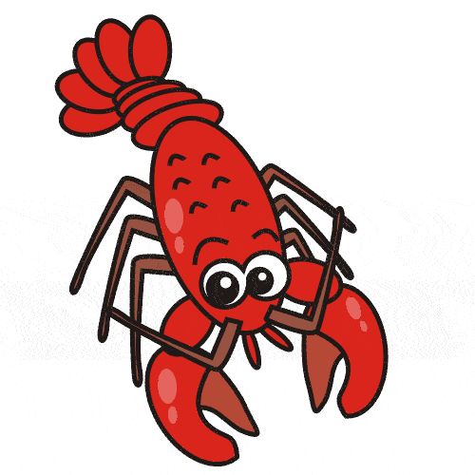

Miramichi East Playground Committee

Father’s Day LOBSTER DRAW ( 50Lbs)
DRAW DATE: JUNE 17, 2016

