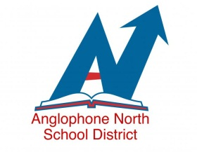
Important Message to Parents and Guardians:
Requests for Alternate Bussing Arrangements
(Bus Passes)

Dear Parents /Guardians,
As you are aware, the safety of your children, our students, is of the utmost importance to us and this includes safe transportation to and from school. The amount of requests schools receive to place students on different school busses is a great concern. This becomes difficult for administration to monitor as large numbers of alternate bus passes are being issued. Young students are often unsure where they are supposed to go and many may be unfamiliar to bus drivers.
You have already provided the school with one alternate bus stop and we are able to accommodate this. School administration has been directed to issue additional alternate bus passes for emergency purposes only. On the rare occasion that this may arise, please make contact with the school by telephone. It is important to speak to someone and not to leave a voice message in case it is not picked up prior to departure.
I would like to thank you for your co-operation as we continue to provide safe transportation for your children.

Sincerely,
Beth Stymiest-Superintendent

