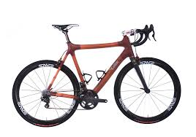 1ST ANNUAL 

TOUR DU MIRAMICHI

BICYCLE RALLY

WHEN : SATURDAY JUNE 4 2016

WHERE : MVHS SCHOOL

TIME : 8AM -2PM

ROUTES WILL BE SETUP FROM 6.5KM TO 64KM

PRIZES & BARBEQUE

YOUTH 14 & UNDER - $10

ALL OTHER PARTICPANTS - $20

GET YOUR BICYCLE TUNED UP YOU WILL NOT WANT TO MISS THIS EVENT

IN SUPPORT OF MIRAMICHI YOUTH SCOUTING

Email : [miramichiscouting@gmail.com](mailto:miramichiscouting@gmail.com) if you plan to participate