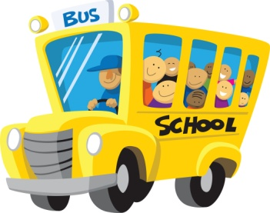**St. Andrew’s Elementary**

**Supplies for Kindergarten**

**2012 – 2013**

* 1 pair of scissors
* 4 medium sized glue sticks
* 2 white erasers
* 1 pkg. HB pencils
* 4 pkg. of crayons (8’s)
* 1 pkg. of Crayola washable markers (large, not fine tip)
* 1 Hilroy scribbler
* 1 Hilroy journal scribbler (top 1/2 is plain with no lines, bottom ½ is ruled with lines)
* 6 duo-tangs
* 2 red
* 1 green
* 1 blue
* 1 orange
* 1 yellow
* 1 double pocket folder
* Lunch bag
* Book bag
* 2 pairs of sneakers – 1 pair for indoor wear only & 1 pair for outdoor wear only (Velcro or elastic laces are great for those who do not know how to tie laces)
* 2 boxes of facial tissue
* 1 box of large size Ziplock bags
* 1 box of medium size Ziplock bags
* 1 pair of headphones with ear muffs (not the ones that go into your child’s ear)

**For work at home, each child will need: **

* 1 pair of scissors
* 1 glue stick
* 1 white eraser
* 1 pkg. of crayons (8’s)
* pencils