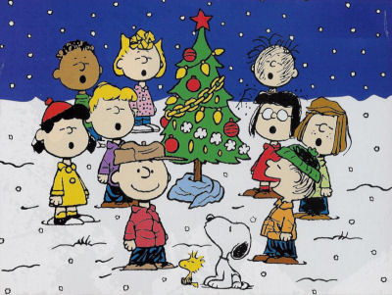
TO: Parents/Guardians
FR: B.Schofield and E.Comeau
RE: Christmas Cocoa House

Saint Andrew’s Elementary School, along with our choir, will be hosting its first Cocoa House on Monday, December 20th beginning at 6:00pm. Our students have lots of talent to share, and some come from very talented backgrounds. That being said, we would like for moms, dads, grampies, grammies, nannies and papas, aunts and uncles to be involved in our celebration. So if you can sing, dance, play musical instruments, tell jokes, we would love to have you come out and show off your talent with your daughter, son, granddaughter, grandson, niece, nephew etc. You, by no means have to be a star, Mrs. Schofield is even going to sing (not solo)! Piano and sound system will be available; all you need to bring is yourself. If you are interested, just fill out the form below, send it back to school with your child and return to Mrs. Schofield on or before Monday, December 13th.

I would love to be a part of Saint Andrews’ Christmas Cocoa House

Name of Saint Andrew’s Student: ________________________________

Name of family member(s) _____________________________________

