Miramichi East Playground Committee Needs Your Vote
Posted: October 5, 2016
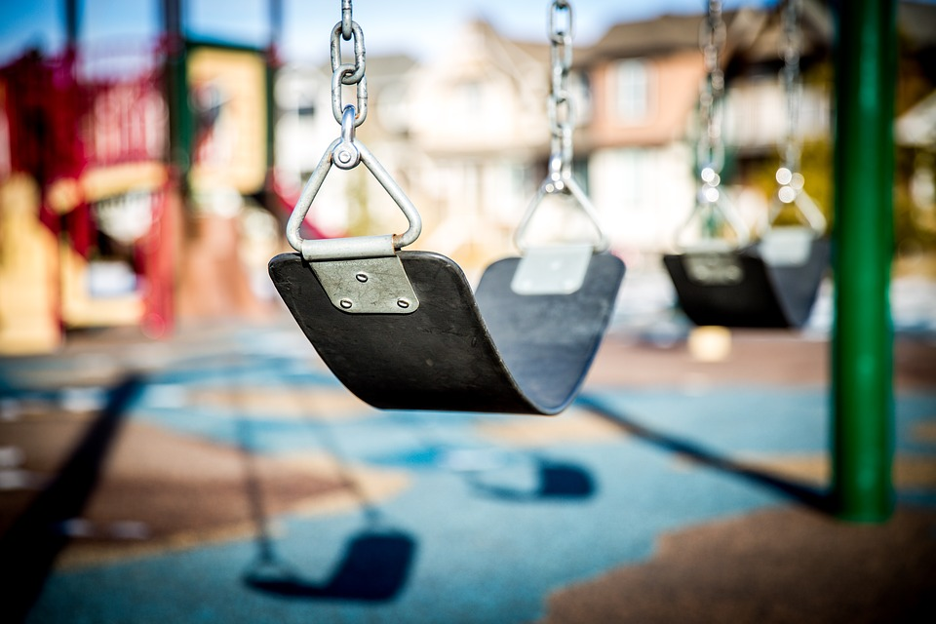
The Miramichi East Playground Committee is entering the Aviva Community Fund Contest. The committee would like everyone in our beautiful community and beyond to vote for the playground. They are hoping to win $100 000 for their cause.
The only way to win is to have the most votes. Different from previous years, Aviva is allowing voters to log in ONCE during the voting period to cast all 18 of your votes. No need to come back every day. Voting open October 11th and runs through to October 28th.
HOW TO VOTE
1. Go to avivacommunityfund.org (link is external)
2. Click on "Login/Register" - the green button at the top right.
3. Enter your information.
4. Vote for our project and use ALL your 18 votes at once for us! Our project is "Building a Future for our Children - The Playground".
5. Share this event to spread the word!
Miramichi East Playground Committee would like everyone to share this event and tell your family & friends. Together we can win this!

