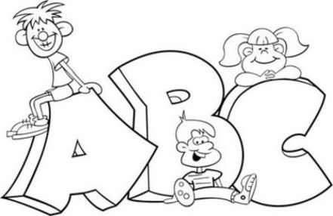
June 15, 2016

Dear Parents/Guardians,

Next week is the last week of school! It is unbelievable how fast the time has gone. There are a number of activities happening next week that I thought you might like to be aware of. Students in our class have also decided on several extra special activities, just for us! Here is our itinerary for next week so you can plan accordingly:

Mon, June 20: School Picture outside at 8:20 AM, followed by the third Awards Ceremony for students. This will also be ‘Craft Day’ in our classroom.

Tues, June 21: K-2 Sports Fun Day, beginning around 9:00 AM, followed by a Dance Party in the gym at 1:00 PM. Please wear sneakers and bring a large water bottle as it is supposed to be hot that day. Students are asked to bring in a donation for the ASCA as part of the Dace Party.

Wed, June 22: Chatham Library presentation at 9:00 AM, followed by St. Andrews’ Got Talent show for most of the day.

Thurs, June 23: Pajama-Movie day (Our class only). We are finishing up reading Charlotte’s Web and plan to celebrate by watching the movie in our pjs and eating cupcakes!

Fri, June 24: Last day of school! Early dismissal at 11:30am (see note that went home on June 14th regarding dismissal).

If you have any questions about these activities please feel free to send in a note or write me an email. I have really enjoyed my time teaching your child these past two months. Have a wonderful summer!

Thank you,

Mrs. Gallant and Mr. Williston

