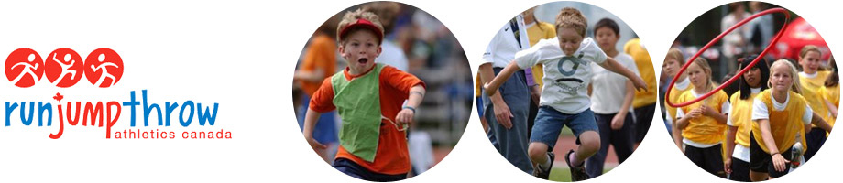
Miramichi Track and Field Club
Does your son or daughter like to run, jump and throw? Well, we have the perfect program for them!
Youth aged 5 to 12 are invited to participate in a Run, Jump, Throw 12 Challenge Series, which will involve 4 evenings of 12 Challenges, planned for Mondays - May 19, 26, June 2 and 9th at the James M Hill track in Miramichi. Three different track and field events are scheduled every week for a total of 12 events (hence the name of the program). The instructors will be trained Run, Jump, Throw instructors.
Categories will be :
Kindergarten to grade 2 students – 6:00 PM to 6:50 PM
Grade 3 to grade 6 students – 7:00 PM to 7:50 PM
Registration fee will be $25 and will be done online on http://www.trackie.com/online-registration/event.php?id=1258
For more information, contact: tammy.stewart@nbed.nb.ca

What is Run Jump Throw?
•A fun and active learning environment
•Individual improvement and positive reinforcement
•Developing the skills of running, jumping and throwing in age appropriate progressions
•Improvement in physical and emotional well-being
•Safe instruction
For more details, check out their website: http://www.athletics.ca/page.asp?id=64

