Monday, October 10

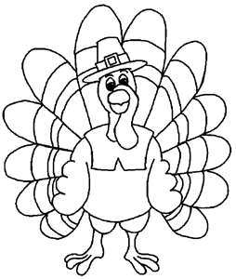Happy Thanksgiving!!
Tuesday, October 4

Spelling – Get test signed. Study your new words.
Math – Complete question on sheet. Study your 6X Tables. Get your math test signed.
Reading – Read for 15 minutes and record on your log sheet.
.
Wednesday, October 5

Spelling – Complete question on sheet. Study your new words.
Math – Complete question on sheet. Study your 6X tables.
Reading – Read for 15 minutes and record on your log sheet.
Library – Bring back your library books to school tomorrow.

Thursday, October 6
Spelling – Study your new words for the test tomorrow.
Math – Complete question on sheet. Study your 6X tables.
Reading – Read for 15 minutes and record on your log sheet.
Phys. Ed – Bring your gym clothes for class tomorrow.

